Google Search

What is a search system?
A search system is a system that takes some text input, a search query, from the user and returns the relevant content in a few seconds or less. There are three main components of a search system, namely:
- A crawler, which fetches content and creates documents.
- An indexer, which builds a searchable index.
- A searcher, which responds to search queries by running the search query on the index created by the indexer.

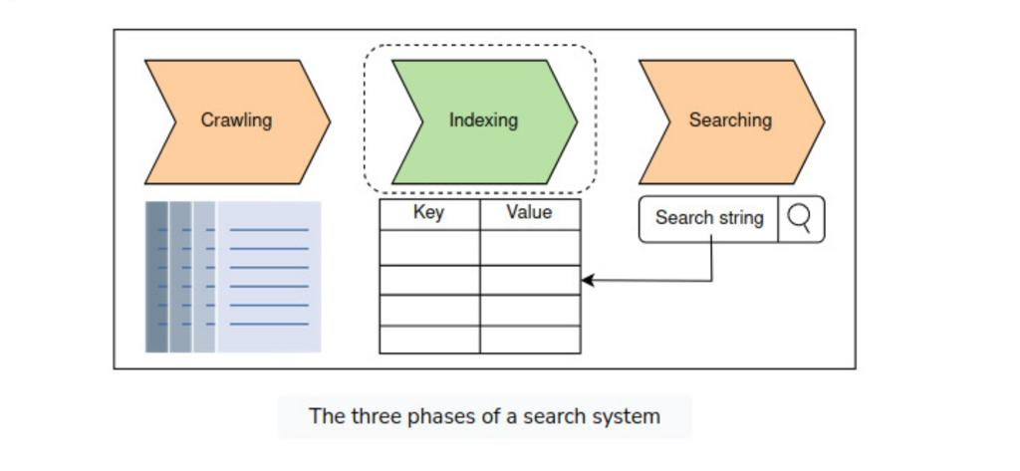

Functional requirements:
- Search: Users should get relevant content based on their search queries.

Non-functional requirements:
- Availability: The system should be highly available to the users.
- Scalability: The system should have the ability to scale with the increasing amount of data. In other words, it should be able to index a large amount of data.
- Fast search on big data: The user should get the results quickly, no matter how much content they are searching.
- Reduced cost: The overall cost of building a search system should be less.

CAPACITY ESTIMATION:

INDEXING:
Indexing is the organization and manipulation of data that’s done to facilitate fast and accurate information retrieval.

Build a simple searchable index:
The simplest way to build a searchable index is to assign a unique ID to each document and store it in a database table, as shown in the following table.

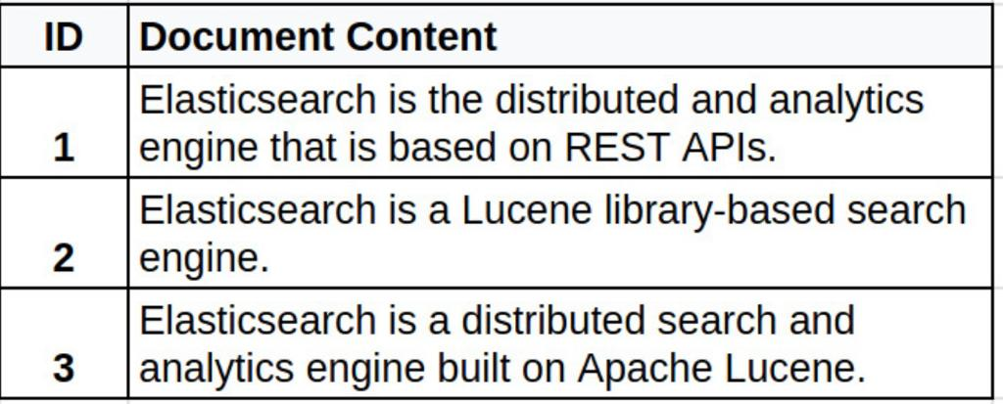

There are some issues with above search indexing:
- Searching on the document-level index is slow because it requires scanning all documents and counting search string occurrences. This slowness becomes pronounced when dealing with billions of documents, taking many minutes or even hours.
- Performing a fuzzy search involves using approximate string matching, which makes the search process more complex. It requires identifying unique candidate strings in all documents, selecting the closest match from these candidates, and finding the occurrences of the closest match in each document. As a result, each fuzzy search query is more time-consuming.

Inverted index:
An inverted index is a HashMap-like data structure that employs a document-term matrix(a mathematical matrix that represents the frequency of terms in a list of documents.). Instead of storing the complete document as it is, it splits the documents into individual words. After this, the document-term matrix identifies unique words and discards frequently occurring words like “to,” “they,” “the,” “is,” and so on. Frequently occurring words like those are called terms. The document-term matrix maintains a term-level index through this identification of unique words and deletion of unnecessary terms.

For each term, the index computes the following information:
- The list of documents in which the term appeared.
- The frequency with which the term appears in each document.
- The position of the term in each document.

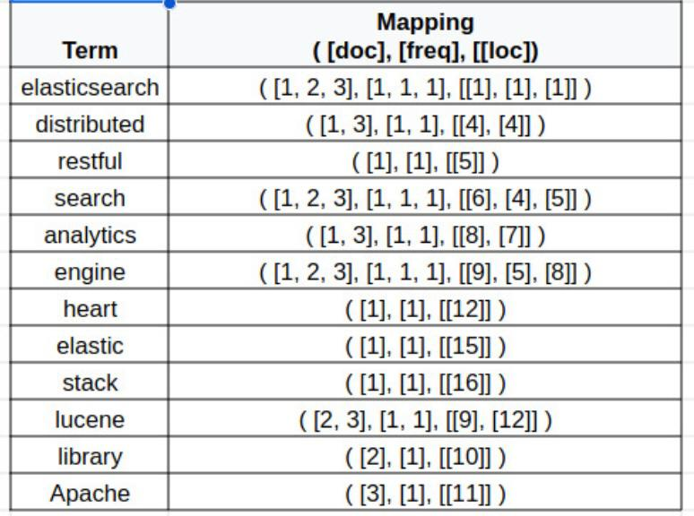

In the table above, the “Term” column contains all the unique terms that are extracted from all of the documents. Each entry in the “Mapping” column consists of three lists:
- A list of documents in which the term appeared.
- A list that counts the frequency with which the term appears in each document.
- A two-dimensional list that pinpoints the position of the term in each document. A term can appear multiple times in a single document, which is why a two-dimensional list is used.
Note: Instead of lists, the mappings could also be in the form of tuples— such as doc, freq, and loc.

Inverted index is one of the most popular index mechanisms used in document retrieval. Some of its advantages and disadvantages are as follows:
- Advantages of using an inverted index:
  - An inverted index facilitates full-text searches.
  - An inverted index reduces the time of counting the occurrence of a word in each document at the run time because we have mappings against each term.
- Disadvantages of using an inverted index:
  - There is storage overhead for maintaining the inverted index along with the actual documents. However, it reduces the search time.
  - Maintenance costs (processing) on adding, updating, or deleting a document. To add a document, we extract terms from the document. Then, for each extracted term, we either add a new row in the inverted index or update an existing one if that term already has an entry in the inverted index. Similarly, for deleting a document, we conduct processing to find the entries in the inverted index for the deleted document’s terms and update the inverted index accordingly.

Searching from an inverted index:
To search for any query, the "query string" is first passed to "lexical engine" which provides "term ids" from that query string. Then we search the inverted index for all the terms of the query string and then we merge the search results for all the terms and then we sort them based on the relevance to the search query. Then the top results are returned to the user with pagination, instead of returning all the documents.

Factors which should be kept in mind while designing an index:
- Size of the index: How much computer memory, and RAM, is required to keep the index. We keep the index in the RAM to support the low latency of the search.
- Search speed: How quickly we can find a word from an inverted index.
- Maintenance of the index: How efficiently the index can be updated if we add or remove a document.
- Fault tolerance: How critical it is for the service to remain reliable. Coping with index corruption, dealing with defective hardware, partitioning, and replication are all issues to consider here.
- Resilience: How resilient the system is against someone trying to abuse the system and guard against search engine optimization (SEO) schemes, since we return only a handful of relevant results against a search.

DESIGNING A DISTRIBUTED INVERTED INDEX:

There are two phases of such a system:
- The offline phase involves data crawling and indexing in which the user has to do nothing.
The indexing is performed offline, and not on the user’s critical path. We don’t need to replicate the indexing operations synchronously. It is not necessary to respond to the user search queries with the latest data that has just been added to the index. So, we don’t have to wait for the replication of the new index to respond to the search queries. This makes the search available to the users. Once we replicate the latest data in all groups of indexing nodes and the search nodes have downloaded it, then the search queries are performed on the latest data.
Note: The web pages, for which faster updates are necessary (for example - web pages of news websites) in the search engine, they can be kept in a separate category and their indexes can be updated at high frequency.
- The online phase consists of searching for results against the search query by the user.

A centarlized single machine search system will look like following:

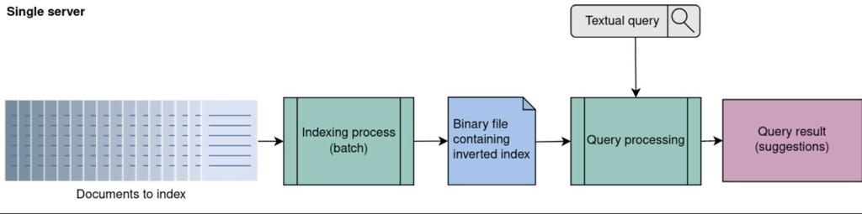
An inverted index needs to be loaded into the main memory when adding a document or running a search query. A large portion of the inverted index must fit into the RAM of the machine for efficiency.

Capacity estimation:
Storage Estimate: According to Google analytics in 2022, there are hundreds of billions of web pages, the total size of which is around 100 petabytes. If we make a search system for the worldwide web, the inverted index size will also be around 10 petabytes. So, total storage required = 200 PB
We should also account for 10% increase in this each year, so in five years the storage requirement will increase to around 300 PB.
Traffic Estimates: Google processes around 8.5 billion searches per day which translates to around 100k QPS.
Number of servers required: Here, we will estimate for two types of servers:
- Index Servers: Total size of index servers is around 100 PB. We will need to store these indexes in the memory (RAM). Modern day servers have around 144 GB memory. So number of index servers required = 70k
- Web Servers: Suppose 1 server can handle 1k requests per second, so total number of servers required = 100. Then we also need these servers replicated for fault tolerance.
Bandwidth estimates: The data is transferred between the user and the server on each search request. We estimate the bandwidth required for the incoming traffic on the server and the outgoing traffic from the server.
- Suppose, each search query request size is 200 Bytes. So, total incoming request per second = 100k per second * 200 Bytes = 20 Mbps
- Suppose, each search response size is approximately 200 KB, so total outgoing response per second data size = 100k per second * 200kb = 20 Gbps
- Suppose, we crawl the whole web data per month. So, total data downloaded per month = 100 PB which translates into around 38 Gbps.
- So total bandwidth required will be around 58 Gbps.

So we understand that we need to build distributed inverted index and serve the requests from multiple machines. High level design of such a distributed inverted index is as follows:

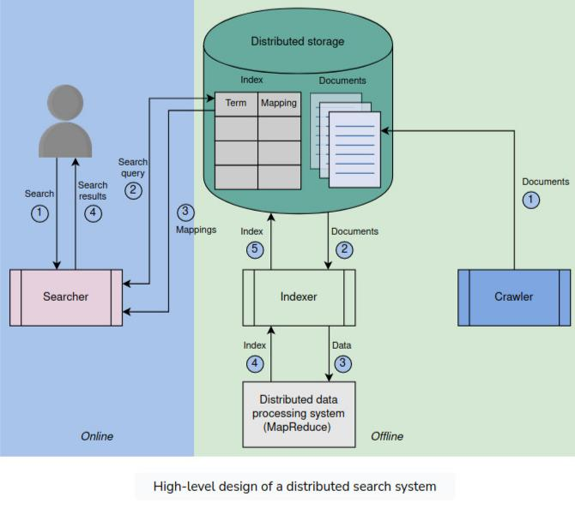

- Crawler: The crawler collects content from the intended resource. For example:
  - if we build a search for a YouTube application, the crawler will crawl through all of the videos on YouTube and extract textual content for each video. The content could be the title of the video, its description, the channel name, or maybe even the video’s annotation to enable an intelligent search based not only on the title and description but also on the content of that video. The crawler formats the extracted content for each video in a JSON document and stores these JSON documents in a distributed storage.
  - if we build search for google, we will need to crawl all the web and to extract all the content bet it html or other documents and then to store it in a distributed storage.
- Cluster Manager: The indexing cluster processes crawled documents by using a cluster manager to divide them into smaller sets for different cluster nodes. The manager determines partition sizes based on data size, computation, memory limits, and cluster node count. The cluster manager also monitors the node health using the periodic heartbeats and does some rearrangements if any node fails.
- Indexer: The indexer fetches the documents assigned to it from the distributed storage and indexes these documents using MapReduce (for parallel and distributed index construction), which runs on a distributed cluster of commodity machines. The constructed index table is stored in the distributed storage.

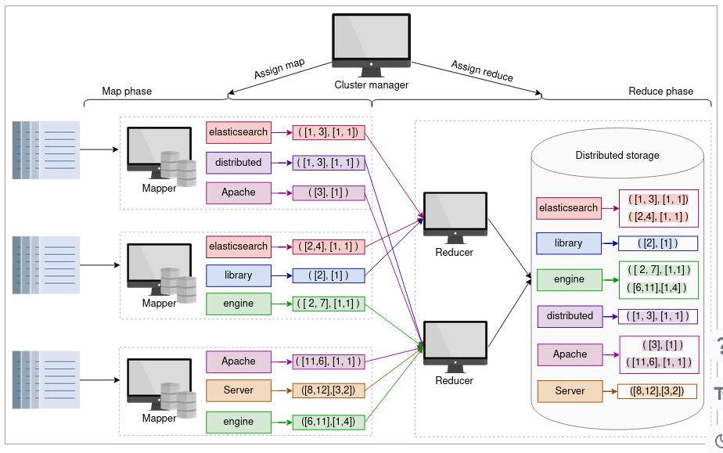
- The distributed storage is used to store the documents and the index.
- This prepared inverted index is replicated all across the globe in various data centers (having multiple copies in each data centre) to facilitate all users as per the requirement. Thus, we can achieve the following advantages:
  - Our design will not be subject to a single point of failure (SPOF).
  - Latency for all users will remain small.
  - Maintenance and upgrades in individual data centers will be possible.
  - Scalability (serving more users per second) of our system will be improved.
- The user enters the search string that contains multiple words in the search bar. This query string request goes to the servers of nearest data centre.
- To search for any query, the "query string" is first passed to "lexical engine" which provides "term ids" from that query string. The lexical engine also intelligently maps the incorrectly spelled words in the search string to the closest vocabulary words. Then we search the inverted index for all the terms of the query string and then we merge the search results for all the terms and then we sort them based on the relevance to the search query. Then the top results are returned to the user with pagination, instead of returning all the documents.

Evaluation of a Distributed Search's Design:
- Availability: We have utilized distributed storage to store these items:
  - Documents crawled by the indexer.
  - Inverted indexes generated by the indexing nodes.
Data is replicated across multiple regions in distributed storage, making cross-region deployment for indexing and search easier. The group of indexing and search nodes merely needs to be replicated in different availability zones. Therefore, we deploy the cluster of indexing and search nodes in different availability zones. So, if a failure occurs in one place, we can process the requests from another cluster. Multiple groups of indexing and search nodes help to achieve high indexing and search availability. Moreover, in each cluster, if a node dies, another can take its place.
- Scalability: Partitioning is an essential component of search systems to scale. When we increase the number of partitions and add more nodes to the indexing and search clusters, we can scale in terms of data indexing and querying.
- Fast search on big data: We utilized a number of nodes, each of which performs search queries in parallel on smaller inverted indices. The result from each search node is then merged and returned to the user.
- Reduced cost: We used cheaper machines to compute indexes and perform searches. If one node fails, we don’t have to recompute the complete index. Instead, some of the documents need to be indexed again.
Abc

